**AWS Cloud Essentials**

* **Cloud Computing:** Stop thinking of your infrastructure as hardware and instead think/use it as software
* AWS is PAYG pricing
* **6 Benefits of cloud computing:**
* **Trade capital expense for variable expense.**
* **Benefit from massive economies of scale.**
* **Stop guessing about capacity.**
* **Increase speed and agility.**
* **Focus on what matters.**
* **Go global in minutes.**
* **3 main cloud computing deployment models:**

1. Cloud – Fully deployed in cloud and all applications run in cloud.
2. Hybrid – Way to connect infrastructure and apps between cloud-based resources and existing resources that are not hosted in the cloud (e.g. on-premises).
3. On-premises – Deploying resources on-premises using virtualization and resource management tools is called private cloud. Doesn’t have many benefits of cloud computing but its good for providing dedicated resources.

* **AWS:** Secure cloud platform that offers a broad set of global cloud-based products. On-demand access to compute, store, network, database and other IT resources and management tools. Flexible. Only pay for what you need and use. Services work together like building blocks.

**AWS Global Infrastructure**

Most secure extensive and reliable cloud computing environment. Flexible, reliable, scalable and secure. Built around 22 regions worldwide.

Resources in one region aren’t automatically replicated in other regions so if you store data in one region, it is your responsibility to replicate data across regions if that’s required.

Select the right region for your services, applications and data based on:

1. Data Governance – legal requirements
2. Proximity to customers – latency (cloudping is a website to test latency)
3. Services available within the region
4. Costs – vary by region.

Each region has multiple availability zones which have their own power infrastructure. Each zone is a fully isolated partition of the AWS infrastructure. Currently 69 worldwide. Consist of data centres. Designed for fault isolation. Zones are interconnected with high-speed private networking. AWS recommends replicating data and resources across zones for resiliency. Having apps across multiple zones, if one goes offline, you still have servers in the other zones.

Data centre – Designed for security. Where data resides and data processing occurs. Typically 50-80,000 physical servers.

**Compute Services AWS:**

* **Elastic Compute Cloud (EC2):** Provides resizable compute capacity as virtual machines in the cloud. Designed to make web-scale cloud computing easier for developers. Compute capacity means functionality traditionally provided by virtual or on-premises physical servers you get the same functionality as you would from a physical server but with benefits of hosting it in the cloud.
* **EC2 autoscaling**: This enables you to automatically add/remove EC2 instances according to your conditions. Helps maintain app availability, auto add/remove EC2 instances according to defined conditions, detects impaired EC2 instances and unhealthy apps and replaces them without your intervention and finally provides several scaling options – Manual, scheduled, dynamic, predictive and on-demand. Dynamic and predictive scaling can be used together to scale faster.
* **Elastic Container Services (Amazon ECS):** Highly scalable and performant container orchestration service that supports docker containers.
* **EC2 Container Registry (ECR):** Fully managed Docker container registry that makes it extremely easy for developers to store, manage and deploy Docker container images.
* **Elastic Beanstalk:** Service for deploying and scaling web applications and services on familiar servers like Apache or Microsoft Internet information services.  **Lambda:** Enables you to run code without provisioning or managing servers. Only pay for the compute you consume—no charge when your code is not running.
* **Elastic Kubernetes Service (EKS):** Makes it extremely easy to deploy, manage and scale containerised applications that use Kubernetes on AWS.
* **Fargate:** Compute engine for ECS that allows you to run containers without having to manage servers or clusters.

Categorizing compute services

**Elastic load balancing** distributes incoming app or network traffic across multiple targets in a single availability zone or across multiple availability zones. It also scales your load balancer as traffic so your applications change over time. Needs to process a high volume of interactions and return the right texts/images/video/app data in a fast and reliable manner. Distributes incoming app/network traffic across multiple targets. Scales your load balancer as traffic to your application changes over time. Can automatically scale to most workloads.

Elastic Load Balancing

**Storage**

* **S3:** Data is stored in buckets. Unlimited storage (single object limited to 5TB). Granular aces to buckets and objects. Can control who can create/retrieve/update objects in the bucket. Can chose the location where the bucket is stored to optimise for latency, minimizing costs or to address regulatory requirements. 11 nines of durability.

EBS

* **EBS:** Persistent block storages for instances, protected through replication, different drive types, scale up or down in minutes, pay for only what you provision, snapshot functionality and encryption is available (encryption will occur both In transit and at rest). Have solid state drives (SSD) or hard disk drives (HDD).
* **EFS FSx:** Perfect for when you have an application running on multiple instances that needs to use the same file system. EBS only attaches to one instances and S3 is an option but not ideal, it is an object store system, not a block store, so it changes overwrite entire files not blocks of characters within the files.
* **S3 Glacier:** Secure, durable, extremely low-cost storage service for data archiving and long term back up. 11 nines of durability. Comprehensive security and compliance capabilities that can help you meet the most stringent regulatory requirements. Typically designed for data – for long term storage and infrequently accessed data

Glacier

**Transfer Family**

**Function:**

For SFTP, FTPS, FTP. Fully managed serviced. Enables the secure transfer of files into and out of Amazon S3 and Amazon EFS.

**Benefits:**

* No infrastructure to set up.
* Operate and manage all the infrastructure necessary to maintain high availability and performance.
* AWS autoscaling means you never have to worry about keeping up with your end user’s data transfer activity and you can seamlessly migrate your workflows to the service, so nothing changes for your partners, customers or internal teams.
* Whether you’re working with large technical documents, media files or invoices, AWS sftp, ftps and ftp supports recurring/occasional data-sharing process.
* With common authentication systems, your users always have the correct, secure access to exchange important files.
* Your files are durably stored In your Amazon S3 bucket or efs file system, enabling you to use them with your crm, erp and web-serving applications, as well as home directories and developer tools, or process them in your data lake with analytics or machine learning to extract business insight.
* Focus on your business and let AWS focus on taking care of your file transfers with their secure, scalable, reliable and fully managed AWS transfer family.

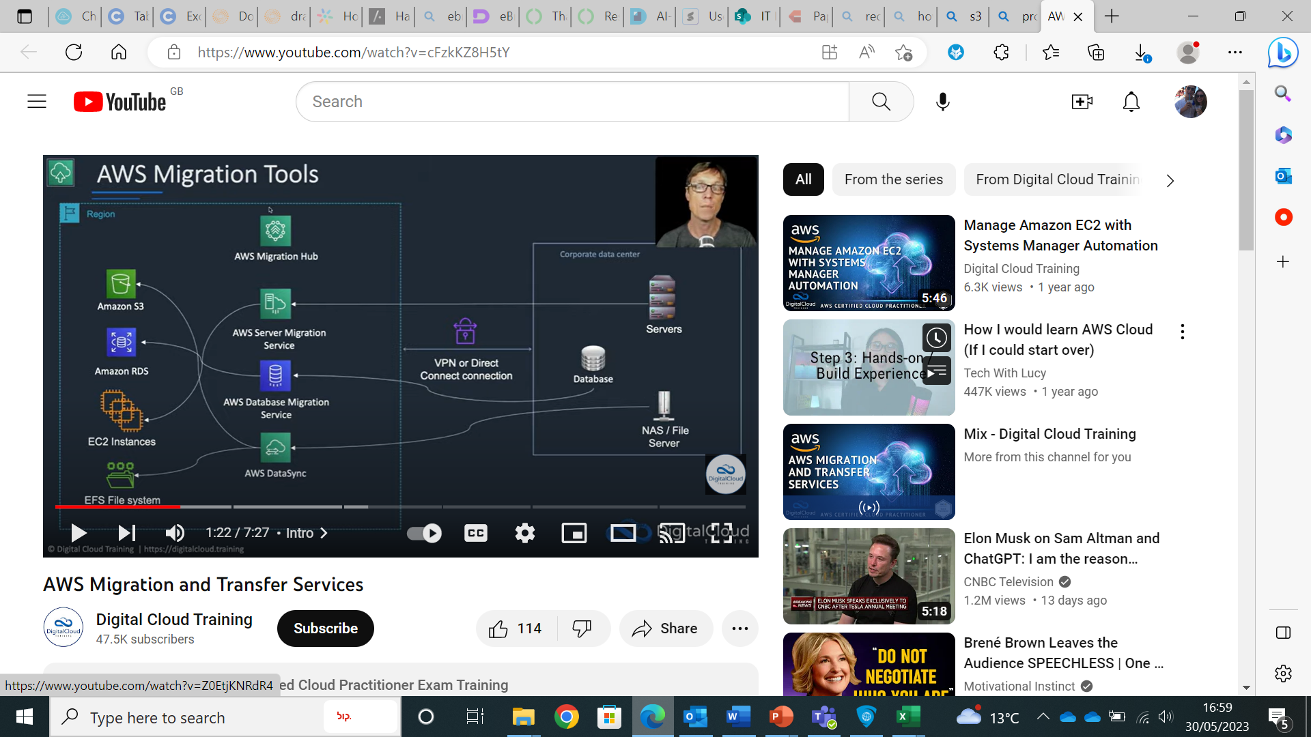

**S3**

**Function:**

Amazon’s simple storage service (S3) is safe, secure object storage. Easy to use with a simple web services interface that can store and retrieve any amount of data at any time from Amazon EC2 or from anywhere on the web. You just choose the region where you want your data stored, create a bucket and you can begin storing your data on S3. You can store as much data as you want and access it when needed. You don’t need to worry about losing data as S3 automatically makes copies of your objects on multiple devices across multiple facilities so you can easily retrieve data if it is accidentally deleted.

Used for backup and restore, data archiving, static web hosting, content distribution, big data analytics and application data storage.

Object Storage:Stores data as objects/files. Each object consists of the data along with its associated metadata and unique identifier.

A bucket contains subfolders and files. Can organise it however suits you.

Can retrieve content in a bucket from a URL (has to be public), programmatically (most common way) and through the AWS console.

Public access is blocked by default.

Useful in a variety of contexts:

* **Website hosting:** Store static content for your website, html, css, JavaScript, and image files.
* **Database backups**
* **Data processing pipelines**

**Advantages:**

* You only pay for the storage you actually use – there is no minimum fee and no set-up cost.
* There is a range of storage classes offered designed for different use cases including **S3 Standard** for general-purpose storage of active data, **S3 Standard Infrequent Access** for long-lived but less active data and **Amazon Glacier** for long-term archived.
* Offers configurable lifecycle policies for managing your data throughout its lifecycle, once a policy is set your data will automatically migrate to the most appropriate storage class without any changes to your apps.
* Securing your data is very important and S3 gives you the flexibility to control who can access your data with Identity and Access management policies, access control lists, bucket policies and query string authentication.
* Very highly durable so very unlikely to lose your data.
* S3 also helps you upload and download your data with SSL encrypted endpoints and provides multiple options for encrypting data at rest. Helps you get the most out of your data by making sure it is stored safely, available when needed and will scale as your needs grow.
* **Auditing:** Supports access logs, action based logs and can set up alarms.
* **High Scalability:** Allowing you to store and retrieve any amount of data. It automatically scales to accommodate your storage needs without any upfront capacity planning.
* **High Durability & Availability:** Replicates data across multiple availability zones within a region ensuring durability even if there are hardware failures or natural disasters.
* **Security:** Offers multiple layers of security to protect your data. You can configure access control policies, set permissions at the object or bucket level and use AWS identity and Access management to manage access to S3 resources.
* **Data management and lifecycle policies:** Features for managing and organising your data. You can create lifecycle policies to automatically transition objects between different storage classes based on pre-defined rules – such as moving infrequently accessed data to lower-cost storage class.
* **Versioning and data replication:** Enables versioning for your objects which keeps track of all versions of an object over time. You can also replicate data between different S3 buckets or even across AWS regions for data redundancy and disaster recovery purposes.
* **Integration with other AWS services:** Seamlessly integrates with other AWS services such as Lambda, Athena, Redshift and EMR, allowing you to build powerful data processing and analytics workflows.

**Alternatives:**

* **Elastic Block Store (EBS):** Stories files in multiple volumes called blocks which act as separate hard drives – block storage devices are more flexible and offer higher performance than regular file storage. Good for business continuity, software testing and database management.
* **Elastic File System (EFS):** Shared elastic file storage systems. Offers a traditional file storage paradigm with data organized in directories and subdirectories. Useful for SaaS apps and content management systems.
* **FSx:** Offers file systems designed for a variety of workload types. You can use AWS FSx as storage for Windows applications, machine learning (ML) and high-performance computing (HPC). FSx can also help with electronic design automation.

**Comparisons:**

* S3 is the cheapest for data storage alone but EFS has the simplest cost structure.
* S3 can be accessed from anywhere. EBS is only available in a particular region. Can share files between regions on multiple EFS instances.
* EBS and EFS are faster, have higher IOPS and lower latency than S3.
* EBS is scalable with an API call. Since EBS is cheaper than EFS you can use it for database backups and other low-latency interactive apps that require consistent, predictable performance.
* EFS is best for large quantities of data, e.g., large analytic workloads. EFS allows concurrent access to thousands of EC2 instances, making it possible to process and analyse large amounts of data seamlessly. Data at this scale cannot be stored on a single EC2 instance allowed in EBS – this requires users to break up data and distribute it between EBS instances.
* FSx has two key differentiators compared to other Amazon’s previous file service offerings, such as Elastic File Service (EFS). It comes with a complete file server built in, and it offers superior performance for demanding use cases.
* In S3 there can’t be any two buckets named the same which is a bit of a constraint.
* There is a limit on the number of files in a bucket (5 terabytes) – large size and will satisfy most use cases.
* S3 storage classes allow you to reduce cost but with certain sacrifices (availability and latency). Examples – Standard, Intelligent, Infrequent Access and Glacier. Using Glacier there will be delays in your data from minutes to potentially hours but the cost is greatly reduced. Overall the pricing and availability is pretty consistent but the latency varies across the storage classes. Standard Tier (Hot Data – frequent and fresh data) -> Infrequent Access -> Glacier (Cold Data – infrequent and old archived data). Can automate Lifecyle rules for the data movement process, configure on bucket or object level.

**Lambda**

Computer service that runs your backend code and responds to events such as object uploads to amazon S3 buckets, updates to amazon DynamoDB tables, data and amazon Kinesis streams or in app activity. Once you have uploaded your code to lambda the service handles all the capacity scaling, patching and administration of the infrastructure to run your code and provides visibility into performance by publishing real-time metrics and logs to amazon cloud watch. All you need to do is write the code. AWS lambda is very low cost and does not require any upfront investment. Charged a low feed per request and for the time your code runs, measured in increments of 100ms. No new languages, tools or frameworks to learn. Can use any third-party libraries (even native ones). The code you run on AWS lambda is called a lambda function. You upload your code as a zip or design it in the integrated development environment (AWS management console) or you can select from a list of function samples that are pre-built for common use cases like image conversion, file compression and change notifications and built-in support for the AWS SDK makes it easy to call other AWS services. Once the function is loaded, you first select the event to monitor such as an Amazon S3 bucket or Amazon dynamo DB table and within a few seconds lambda will be ready to trigger your function automatically when an event occurs. An event can trigger your function making it easy to build apps that respond quickly to new information.

1. Allows you to execute your code in response to various events or triggers (like changes to data in an S3 bucket, updates to the database or HTTP requests). You can write your code in a supported language (like Python, Node, Java, C#) and upload it to lambda.
2. Follows event-driven architecture (your code is executed in response to a specific event). Lambda automatically scales the infrastructure to handle the event and executes your code in a stateless environment.
3. Automatically scales the compute resources based on the incoming workload. Provisions the necessary resources to handle concurrent invocations of your code and ensure high availability.
4. Pay-per-use pricing model. Only charge for the execution time of your code, no charges when your code isn’t running.
5. Integrates seamlessly with other AWS servicese so you can build serverless apps/automate workflows.
6. Build serverless apps by combining multiple lambda functions and coordinating them using event-driven triggers. Enables you to develop scalable and cost-effective apps that respond to events in real-time.
7. Various deployment options, including AWS management console, AWS command line interface or AWS CloudFormation templates, CI/CD pipelines or AWS SDK’s.

Simplifies the process of building scalable, even-driven applications by abstracting away the infrastructure management, allowing developers to focus on writing and deploying code.

Accepts the inputs of the primary keys, looks up the DynamoDB table, and returns all the key-value data.

AWS Lambda is a useful tool, allowing the developer to build serverless function on a cost per usage-based. You also benefit from the faster development, easier operational management, and scalability of FaaS.

**Alternatives:**

**Amazon Sage Maker:** Amazon SageMaker is a fully managed platform that enables developers and data scientists to quickly and easily build, train, and deploy machine learning (ML) models at any scale. When you deploy an ML model, Amazon SageMaker leverages ML hosting instances to host the model and provides an API endpoint to provide inferences. It may also use [AWS IoT Greengrass](https://aws.amazon.com/greengrass).

**Comparisons:**

* A screenshot of a computer

  Description automatically generatedThanks to Amazon SageMaker’s flexibility, which allows deployment to different targets, there are situations when hosting the model on [AWS Lambda](https://aws.amazon.com/lambda) can provide some advantages. Not every model can be hosted on AWS Lambda, for instance, when a GPU is needed. Also, there are [other limits](https://docs.aws.amazon.com/lambda/latest/dg/limits.html), like the size of AWS Lambda’s deployment package, which can prevent you from using this method. When using AWS Lambda is possible, this architecture has advantages like lower cost, event triggering, seamless scalability, and spike requests. For example, when the model is small and not often invoked, it may be cheaper to use AWS Lambda.

**DynamoDB**

Fully managed NoSQL database. Provides fast and predictable performance at any scale and is commonly used in apps that require low-latency data access with high scalability.

Cloud database.

Key features:

1. **NoSQL database:** Doesn’t use the traditional relational data model with tables, rows and columns but instead lets you store and retrieve data using a simple key-value interface.
2. **Fully managed service:** AWS handles the operational aspects of database management (like hardware provisioning, configuration, software patching and backups). Allows developers to focus on building apps rather than managing infrastructure.
3. **Scalability and high performance:** Designed to scale automatically in response to traffic patterns and data volume. It can handle millions of requests per second and can support both low and high traffic apps. Single digit millisecond latency for data retrieval.
4. **Data replication and availability:** Automatically replicates data across multiple availability zones within a region to provide high availability and durability. This ensures your data Is protected against hardware failures and your apps can continue to operate without interruption.
5. **Flexible data model:** Supports complex data-structures such as lists, sets and maps. This flexibility allows you to model a wide range of data types and relationships in your apps.
6. **Query and Indexing:** Provides flexible querying capabilities. You can perform fast lookups using primary keys and you can create secondary indexes to enable efficient querying on other attributes of your data.
7. **Security and access control:** Integrates with AWS identity and access management (IAM), allowing you to define fine-grained access control policies to secure your data. You can control who can read and write data, and you can enable encryption at rest and in transit.

DynamoDB is a powerful and highly scalable NoSQL database service. It is well suited for apps that require low-latency data access, high availability and automatic scalability.

Used as a central location to store and update all key-value pairs used in the ‘Mappings’ and ‘Parameters’ sections of the CloudFormation template. This could be a centralized table for the whole organization, with a partition key consisting of the team name and environment (for example, development, test, production) and a sort key for the application name.

[DynamoDB](https://aws.amazon.com/dynamodb/?c=9&pt=2) is a high-performance managed NoSQL database that supports both key-value and document store. It can handle more than 10 trillion requests per day, with peaks of more than 20 million requests per second.

This durable and secure database with built-in in-memory caching, backups, and restore is the number one choice for many fastest-growing startups that demand low-latency data storage at any scale.

**Red Shift**

A fully managed data warehousing service. It is designed to analyse large amounts of data using a columnar storage architecture and massively parallel processing (MPP) techniques. World’s most widely used cloud data warehouse.

Amazon Redshift is built for online analytical processing (OLAP) workloads and is optimized for querying and aggregating large datasets. It allows you to run complex analytic queries across your data using SQL-like queries. Redshift can handle petabytes of data and provides high performance and scalability.

Gather’s information from many sources. It assists you with getting connections across your data.

Key features of Amazon Redshift include:

1. **Columnar Storage**: Organizes data by column rather than by row, which allows for efficient compression and faster query performance. It only accesses the columns that are needed for a specific query, reducing the amount of data read from the disk.

2**. Massively Parallel Processing (MPP):** Redshift distributes data and query execution across multiple nodes, allowing for parallel processing of queries. This enables high-performance queries on large datasets.

3**. Advanced Compression:** Redshift uses various compression techniques, such as column compression, to minimize the amount of disk space required to store data. This reduces storage costs and improves query performance by reducing disk I/O.

4. **Automatic Scaling:** Redshift can automatically scale up or down based on the demands of your workload. You can add or remove nodes to increase or decrease computing power and storage capacity as needed, without significant downtime.

5**. Integration with Other AWS Services**: Redshift integrates with other AWS services such as Amazon S3 for data loading and unloading, AWS Glue for data cataloguing, and AWS Identity and Access Management (IAM) for access control.

Amazon Redshift is commonly used for data warehousing, business intelligence, data analytics, and reporting purposes. It allows organizations to store and analyze vast amounts of data, enabling data-driven decision-making and insights.

Data warehouse which brings together datasets from across organisation to one place so it can easily be queried. Good for distributing workloads. Supports petabytes of data. Optimized for large queries – will optimize the frequently used queries. More suitable for analytics, BI, data mining styled queries compared to RDS, use RDS for smaller queries which take place on a more frequent basis.

Offers elastic scaling to increase/decrease nodes to clusters (this will use on demand pricing which is more expensive than reserve pricing). Managed service (almost 0 maintenance). Hands off experience, aws does most the work. Optimized query performance, consistent and reliable. Can support thousands of users in a single cluster. Flexible pricing. Integrates well with other AWS services.

**Comparisons:**

* RDS better for smaller and frequent queries
* Athena has very inconsistent performance – don’t get allocated resources. Large queries can sometimes take several hours. Basically first come first serve.
* Elastic MapReduce (EMR) better suited if you have a particular analysis that you’re trying to run on a very specific dataset that’s extremely large and has a very repetitive task then EMR more suited. But if doing general data mining, analytics, BI style queries then redshift should be the choice for you.

**EC2**

A set of fully managed AWS services and capabilities. Enable automated configuration and ongoing management of systems at scale. Helps accelerate the journey to the cloud. Flexible and easy to use automation-focused approach.

Key benefits of systems manager:

1. Hybrid – You have a single consistent experience and set of tools to configure and manage your infrastructure, ireespective of where that infrastructure reseides. Whether its AWS or on-premises data centre.
2. Cross-platform support – Provides first class support for windows and linyx platofrms and you no longer have to worry about managing different tools for different platoforms.
3. Scalabale – It is built for cloud scale and is built for both long running instances as well as envrioments that scale quickly and that are toned down later to meet customer demand.
4. AWS Optimized – You get native integration with all of AWS best of breed services such as Iam for access control**, cloud clear** for auditing**, cloud auch events** for driven automation.
5. No additional charge – No longer have to worry about complex licencing models.

Systems manager provides extensible building blocks and services that allow you to build value-added solutions on top.

**What problems does a systems manager solve:**

1. Traditional IT toolsets are not designed and built for cloud scale that emphasises agility and elasticity.
2. Deploying and maintaining multiple management products is a significant operational overhead – it takes a lot of time and effort to simply perform ongoing maintenance of the solution itself.
3. Licensing cost and complexity – It’s hard to plan how much you’ll spend on your management solution.

Systems manager fits very nicely into how you use your existing AWS configuration management tool.

**Key capabilities:**

1. Run command – provides a simple way of remotely executing administrative tasks without having to SSH or RDP into your instances anymore. These tasks could be installing software, system monitoring or making any sort of configuration changes to your operating system or software. These changes can be made on isntances on EC2 aswell as in your on-premises data centres as well.
2. State Manager – Define and maintain a desired state of your instances and maintain consistent operating system configurations like firewall settings and anti-malwear definitions. You can monitor the configuration of a large set of instances, specify configuration for your instances and automatically apply updates or configuration changes to your feed.
3. Inventory – Helps collect and query configuration and software inventory information about your instances and whats installed on them. Gather details about your instances (like installed applications, agent detail and any custom software inventory items). Can also run queries to track and audit your system configuration.
4. Patch Manager – helps you select and deploy operating systems and software patches automatically, across large group of instances – ensuring your software is always up to date and meets compliance policies. You can also define a maintenance window for patches to be applied only during set times that fit your needs.
5. Automation – Simplifies the process of creating and updating amazon machine images through a workflow based approach. You can apply patches, update drivers and agents or bake applications into your amazon machine image using a streamline, repeatbale and auditable process.
6. Parameter store – Allows you to securely store, control access and easily reference your configuration data. Configuration data can be plain text data or secret (passwords). Parameters can be referenced across AWS services such as Amazon, ECS, AWS Lambda and systems manager capabilities like RAM commands, state manager and automation.
7. Maintenance windows – improve availability and reliability of your workloads by automatically performing and scheduling disruptive tasks in a well defined time window. Has built in integration with RAM command and patch manager.

Building Blocks:

1. SSM Agent – Processes and executes and tasks or configuration you specify through any of these services. Open sourced and is available on github.
2. Document – Where you define your configuration for the tasks you want to perform on your infrastructure. Essentially a series of steps that execute in sequence. Can be used across systems manager services such as RAM command, state manager and automation.

**Computation Unit**

**Step Functions**

Service that makes it easy to coordinate the components of distributed apps and microservices using visual workflows.

Deployed using a lambda function. Use it to organise if you want a lambda function to follow another lambda function or to run two functions at the same time. The step function visualises your workflow. Manages and keeps track of each execution. Manages task timeouts, retries and air messages. Examples: Active synchronisation of 2 AWS S3 buckets, requesting human approval by email and wating for the response before continuing the workflow. Helps increase productive time spent on business logic instead of pluming, makes apps more agile and provides resilience at scale.

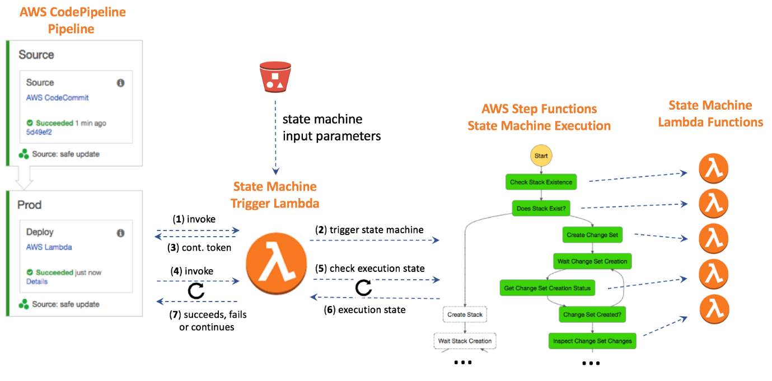Many apps requires more than one function, it is common to have combinations and patterns of two or three functions. Step functions enables you to coordinate your workflows.

**Dashboarding**

**QuickSight**

Connects to your data in the cloud and combines data from many different sources. QuickSight can include AWS data, third-party data, big data, spreadsheet data, SaaS data, B2B data and more. Fully managed cloud-based service. Provides enterprise-grade security, global availability and built-in redundancy. Create dashboard to give decision makers the opportunity to explore and interpret information in an interactive visual environment.

Its claim to fame is to provide a faster, easier-to-use business intelligence tool compared to other tools in the market. Another big selling point? QuickSight is cost-effective, offering cheaper pricing per user compared to other business intelligence tools.

**Benefits:**

* You can get blazing fast responses when the data is retrieved to build dashboards.
* You can combine a variety of data from a variety of sources into a single analysis.
* You can easily publish dashboards and easily control features available in those dashboards.
* You can take advantage of automated and customizable data insights that are powered by machine learning. This means you can take advantage of forecasting, identifying any outliers, anomaly detection, finding hidden trends, and use these to act on key business drivers (enterprise edition).
* The ability to federate users, groups, and single sign-on with IAM Federation, SAML, open ID connect, or AWS Directory Service for Microsoft Active Directory (enterprise edition).
* For security, you have the ability to grant granular permission to AWS data, grant row level access, encrypt the data at rest, and also access private data on-prem or in AWS virtual private cloud (or VPC).

**Pros:**

* SPICE (super-fast parallel in-memory calculation engine) allows you to take advantage of blazing-fast responses when interacting with dashboards. Its integration with AWS data sources and non-AWS sources is simple and easy to set up.
* The interface that AWS provides is intuitive, and it’s easy to learn how to use. They make it pretty simple to create some stunning visualizations.
* As a BI tool, there is no need to license software and set up and maintain infrastructure. And finally, you only pay for what you use. Even if you have an unpredictable number of users, the pay-per-session pricing model is cost-effective. There are no upfront costs or long-term commitments.

**Cons:**

* QuickSight does have a variety of visualization types. However, some useful visualization types are notably missing. For example, candlestick graphs, Gantt charts, and high and low close charts. As QuickSight grows as a service, more of these visualization types may be integrated. So stay tuned.
* Another con is how data that is stored in SPICE is refreshed. Depending on your QuickSight edition subscription, your dashboards can be automated to refresh at a minimum of every hour. If you have a need to create real-time dashboards and visualizations, event-driven-based architectures will need to be used to automate the refresh of your SPICE data sets. For example, using AWS Glue and Lambda to create an ETL pipeline to automatically refresh your SPICE datasets.

**Alternatives:**

* **OpenSearch:** Unlocks real-time search, monitoring and analysis of operational data. Industry use cases – Application monitoring, security monitoring, e-commerce platform, recommendation engine. Good for:
  + **Log Analytics:** Locate, diagnose and remediate issues with your infrastructure and AWS services. Improve your product’s latency and stability.
  + **Search:** Find the right product, service, document, or answer quickly, across semi-structured and unstructured data and different facets and attributes
* **Grafana:**  A popular open-source analytics platform that enables you to query, visualize, and alert on your metrics, logs, and traces.

**Comparisons:**

Grafana:

* Grafana is only supported on a SaaS/Web service whereas quicksight supports SaaS/Web, iPhone, iPad and andr1oid. Quicksight offers API, Grafana does not. Grafana focuses more on tracking operational metrics, logs, and traces from various sources, while QuickSight focuses more on business intelligence and analytics.

**Adobe Campaign Features**

**Make Email Personal:** Personalized and contextually relevant emails. Improve your email automation, deliverability and reporting.

**Cross-channel Marketing:** Harmonize all your marketing channels. Bring customer data from different systems, devices and channels into a single profile. Then deliver timely and relevant campaigns that meet your customers in the right places and right ways along their customer journey.

**Segmentation and Targeting:** Helps you use data to understand your unique customer segments and craft the best campaigns to make meaningful connections with each one.